**Checklist M&E OD API**

1. **Get list**

|  |  |
| --- | --- |
| Method | Endpoint |
| POST | /api-checklist/v1/od/list |

|  |  |  |
| --- | --- | --- |
| Params | Data type | Description |
| Code_Prov_T | String | To filter any record under province |
| Code_OD_T | String | To filter any record under od |

|  |
| --- |
| Response as Json |
| [  {  "Rec_ID": 5,  "Code_Prov_T": "04",  "Code_OD_T": "0401",  "VisitDate": "2021-07-08",  "CheckFrom": "2022-01",  "CheckTo": "2022-03",  "VisitorName": "Sok Kimleng",  "VisitorSex": "M",  "Part1Score": 50,  "Part2Score": 9.9,  "Part3Score": 10,  "Part4Score": 30  }  ] |

1. **Get detail**

|  |  |
| --- | --- |
| Method | Endpoint |
| POST | /api-checklist/v1/od/detail |

|  |  |
| --- | --- |
| Params | Data type |
| Rec_ID | int |

|  |
| --- |
| Response as Json |
| {  "Rec_ID": 5,  "Code_Prov_T": "04",  "Code_OD_T": "0401",  "VisitDate": "2021-07-08",  "CheckFrom": "2022-01",  "CheckTo": "2022-03",  "VisitorName": "Sok Kimleng",  "VisitorSex": "M",  "Part1Score": 50,  "Part2Score": 9.9,  "Part3Score": 10,  "Part4Score": 30,  "MissionNo": "123ABC",  "Participants": [  {  "name": "តារ",  "position": "សិករ"  },  {  "name": "នារី",  "position": "កសិករ"  }  ],  "Detail": {  "P1Q1_1": { "Answer": {…}, "Score": 10 },  "P1Q1_2": { "Answer": {…}, "Score": 10 },  "P1Q1_3": { "Answer": {…}, "Score": 10 },  "P1Q2_1": { "Answer": {…}, "Score": 10 },  "P1Q2_2": { "Answer": {…}, "Score": 10 },  "P1Q2_3": { "Answer": {…}, "Score": 10 },  "P1Q3_1": { "Answer": {…}, "Score": 10 },  "P1Q3_2": { "Answer": {…}, "Score": 10 },  "P1Q3_3": { "Answer": {…}, "Score": 10 },  "P1Q4": { "Answer": {…}, "Score": 10 },  "P1Q5": { "Answer": {…}, "Score": 10 },  "P1Q6": { "Answer": {…}, "Score": 10 },  "P1Q7": { "Answer": {…}, "Score": 10 },  "P1Q8_1": { "Answer": { "plan": 2, "result": 2 }, "Score": 10 },  "P1Q8_2": { "Answer": { "plan": 2, "result": 2 }, "Score": 10 },  "P1Q8_3": { "Answer": { "plan": 2, "result": 2 }, "Score": 10 },  "P2Q1": { "Answer": {…}, "Score": 10 },  "P2Q2": { "Answer": {…}, "Score": 10 },  "P2Q3": { "Answer": {…}, "Score": 10 },  "P2Q4": { "Answer": {…}, "Score": 10 },  "P2Q5": { "Answer": {…}, "Score": 10 },  "P3VMW_Test": { "Answer": {…}, "Score": 10 },  "P3VMW_Positive": { "Answer": {…}, "Score": 10 },  "P3VMW_Pf": { "Answer": {…}, "Score": 10 },  "P3VMW_Pv": { "Answer": {…}, "Score": 10 },  "P3VMW_Mix": { "Answer": {…}, "Score": 10 },  "P3VMW_Minor": { "Answer": {…}, "Score": 10 },  "P3VMW_Severe": { "Answer": {…}, "Score": 10 },  "P3VMW_Death": { "Answer": {…}, "Score": 10 },  "P3VMW_Report": { "Answer": {…}, "Score": 10 },  "P3HC_Test": { "Answer": {…}, "Score": 10 },  "P3HC_Positive": { "Answer": {…}, "Score": 10 },  "P3HC_Pf": { "Answer": {…}, "Score": 10 },  "P3HC_Pv": { "Answer": {…}, "Score": 10 },  "P3HC_Mix": { "Answer": {…}, "Score": 10 },  "P3HC_Minor": { "Answer": {…}, "Score": 10 },  "P3HC_Severe": { "Answer": {…}, "Score": 10 },  "P3HC_Death": { "Answer": {…}, "Score": 10 },  "P3HC_Report": { "Answer": {…}, "Score": 10 },  "P4Q1": { "Answer": {…}, "Score": 10 },  "P4Q2": { "Answer": {…}, "Score": 10 },  "P4Q3": { "Answer": {…}, "Score": 10 },  "P4Q4": { "Answer": {…}, "Score": 10 },  "P4Q5": { "Answer": {…}, "Score": 10 },  "P5Q1": { "Answer": {…}, "Score": 10 },  "P5Q2": { "Answer": {…}, "Score": 10 }  }  } |

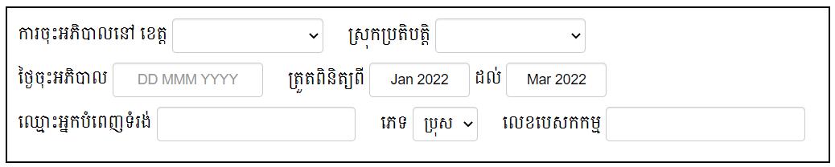

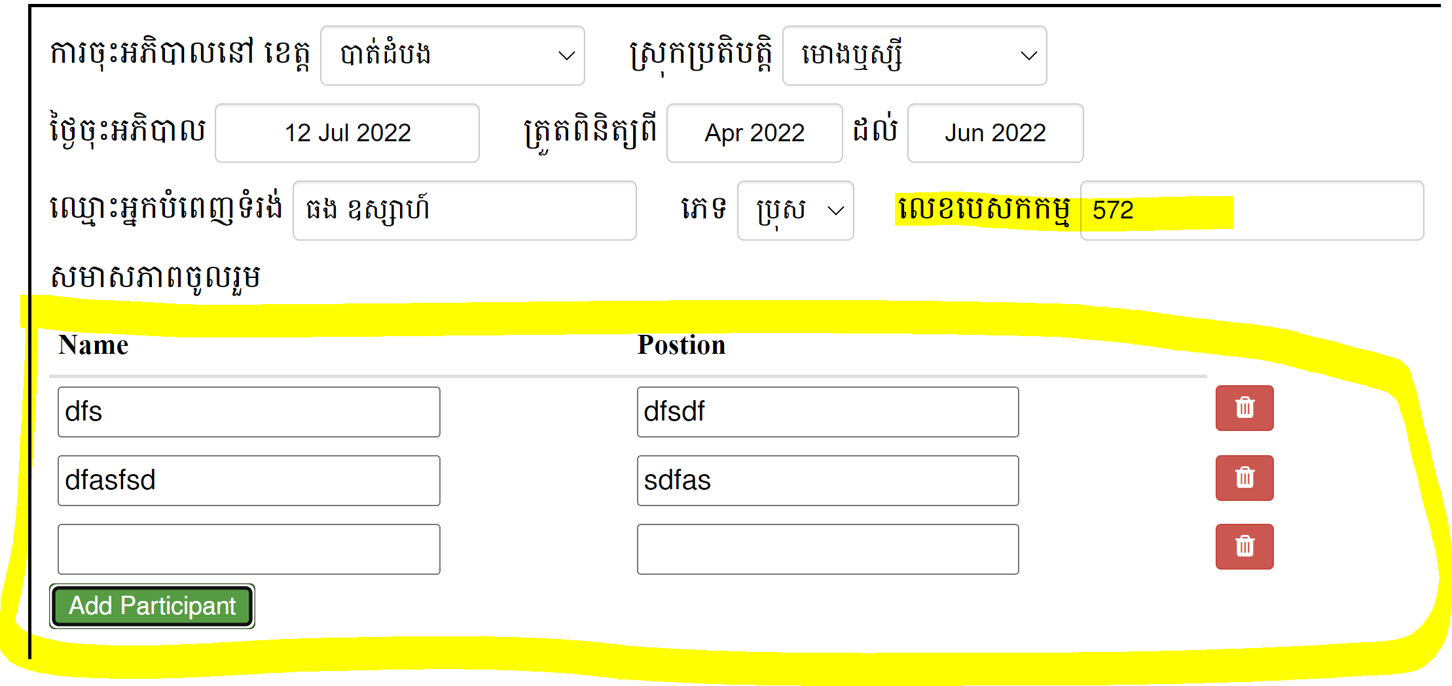

1. **Insert data & Update data**

|  |  |
| --- | --- |
| Method | Endpoint |
| POST | /api-checklist/v1/od/update |

|  |
| --- |
| Object |
| {  "Rec_ID": 0 or 123, (0 for insert, number for update)  "Code_Prov_T": "04",  "Code_OD_T": "0401",  "VisitDate": "2021-07-08",  "CheckFrom": "2022-01",  "CheckTo": "2022-03",  "VisitorName": "Sok Kimleng",  "VisitorSex": "M",  "Part1Score": 50,  "Part2Score": 9.9,  "Part3Score": 10,  "Part4Score": 30,  "MissionNo": "123ABC",  "Participants": [  {  "name": "តារ",  "position": "សិករ"  },  {  "name": "នារី",  "position": "កសិករ"  }  ],  "Detail": {  "P1Q1_1": { "Answer": {…}, "Score": 10 },  "P1Q1_2": { "Answer": {…}, "Score": 10 },  "P1Q1_3": { "Answer": {…}, "Score": 10 },  "P1Q2_1": { "Answer": {…}, "Score": 10 },  "P1Q2_2": { "Answer": {…}, "Score": 10 },  "P1Q2_3": { "Answer": {…}, "Score": 10 },  "P1Q3_1": { "Answer": {…}, "Score": 10 },  "P1Q3_2": { "Answer": {…}, "Score": 10 },  "P1Q3_3": { "Answer": {…}, "Score": 10 },  "P1Q4": { "Answer": {…}, "Score": 10 },  "P1Q5": { "Answer": {…}, "Score": 10 },  "P1Q6": { "Answer": {…}, "Score": 10 },  "P1Q7": { "Answer": {…}, "Score": 10 },  "P1Q8_1": { "Answer": {…}, "Score": 10 },  "P1Q8_2": { "Answer": {…}, "Score": 10 },  "P1Q8_3": { "Answer": {…}, "Score": 10 },  "P2Q1": { "Answer": {…}, "Score": 10 },  "P2Q2": { "Answer": {…}, "Score": 10 },  "P2Q3": { "Answer": {…}, "Score": 10 },  "P2Q4": { "Answer": {…}, "Score": 10 },  "P2Q5": { "Answer": {…}, "Score": 10 },  "P3VMW_Test": { "Answer": {…}, "Score": 10 },  "P3VMW_Positive": { "Answer": {…}, "Score": 10 },  "P3VMW_Pf": { "Answer": {…}, "Score": 10 },  "P3VMW_Pv": { "Answer": {…}, "Score": 10 },  "P3VMW_Mix": { "Answer": {…}, "Score": 10 },  "P3VMW_Minor": { "Answer": {…}, "Score": 10 },  "P3VMW_Severe": { "Answer": {…}, "Score": 10 },  "P3VMW_Death": { "Answer": {…}, "Score": 10 },  "P3VMW_Report": { "Answer": {…}, "Score": 10 },  "P3HC_Test": { "Answer": {…}, "Score": 10 },  "P3HC_Positive": { "Answer": {…}, "Score": 10 },  "P3HC_Pf": { "Answer": {…}, "Score": 10 },  "P3HC_Pv": { "Answer": {…}, "Score": 10 },  "P3HC_Mix": { "Answer": {…}, "Score": 10 },  "P3HC_Minor": { "Answer": {…}, "Score": 10 },  "P3HC_Severe": { "Answer": {…}, "Score": 10 },  "P3HC_Death": { "Answer": {…}, "Score": 10 },  "P3HC_Report": { "Answer": {…}, "Score": 10 },  "P4Q1": { "Answer": {…}, "Score": 10 },  "P4Q2": { "Answer": {…}, "Score": 10 },  "P4Q3": { "Answer": {…}, "Score": 10 },  "P4Q4": { "Answer": {…}, "Score": 10 },  "P4Q5": { "Answer": {…}, "Score": 10 },  "P5Q1": { "Answer": {…}, "Score": 10 },  "P5Q2": { "Answer": {…}, "Score": 10 }  }  } |

|  |
| --- |
| Response as Json (Insert data only) |
| { "Rec_ID": 1 } |

1. **Delete data**

|  |  |
| --- | --- |
| Method | Endpoint |
| POST | /api-checklist/v1/od/delete |

|  |  |
| --- | --- |
| Params | Data type |
| Rec_ID | int |

1. **Get additional data**

|  |  |
| --- | --- |
| 1. Method | Endpoint |
| POST | /api-checklist/v1/od/misdata |

|  |  |
| --- | --- |
| Params | Data type |
| Code_OD_T | String |
| CheckFrom | String (2021-01) |
| CheckTo | String (2021-03) |

|  |
| --- |
| Response as Json |
| {  "stockReport": 100,  "stockACT": 95,  "stockRDT": 100,  "vmwTest": 4522,  "vmwPositive": 22,  "vmwPf": 0,  "vmwPv": 22,  "vmwMix": 0,  "vmwMinor": 4522,  "vmwSevere": 0,  "vmwDeath": 0,  "vmwReport": 100,  "hcTest": 1675,  "hcPositive": 3,  "hcPf": 1,  "hcPv": 2,  "hcMix": 0,  "hcMinor": 1675,  "hcSevere": 0,  "hcDeath": 0,  "hcReport": 96,  "Pf": 1,  "Pv": 24,  "Mix": 0,  "PfL1": 0,  "PfLC": 1,  "PvL1": 2,  "PvLC": 13,  "MixL1": 0,  "MixLC": 1,  "PfFoci": 0,  "MixFoci": 0  } |